Format Requirements for ICG2026 Abstract

- The abstract shall be written in English and confined to one page. The word count is flexible, with a recommended range of 250–500 words.
- The top margin shall be set at 3 cm, while the bottom, left, and right margins shall be set at 2.2 cm. Single line spacing for all context.
- The title should be set in bold 13-point Times New Roman, other content shall be formatted in 11-point Times New Roman, and the institutional affiliation information presented in italics.
- You may opt for either a structured abstract (see Template 1) or an unstructured abstract (see Template 2, single paragraph).
- The structured abstract should includeTitle, Authors, Authors’ affiliations, Corresponding author’s E-mail, Main text (Objective, Methods, Results, and Conclusion), and Keywords.
- Keywords shall be concise and specific, with a required number of 3 to 6.
- References should never be cited in the abstract.
- Provided that all content is limited to one page, authors may include one figure or table (see Template 1). If included, the figure or table must be explicitly cited within the abstract.
- Abbreviations should be used sparingly and must be defined in the first appearance.
- All weights and measures shall be expressed in the SI (metric) unit system, and temperatures in the Celsius (centigrade) scale. Gene nomenclature, species scientific names, and statistical P-values shall be presented in italics, with the P in P-values capitalized.
- The submitted document (.doc or .docx) shall be editable in Microsoft Word (2016 or later) to facilitate subsequent compilation and editing.
- All abstracts must be submitted online. Should you encounter any issues during the submission process, please contact Dr. Jipan Zhang (jpanzhang@live.com) with the email subject specified as ICG2026-Abstract-YourName.-

Template 1:
Effect of number and area of view-fields on the measurement accuracy of hair follicle density in goats (Capra hircus)
Jipan Zhang¹, Chengchen Deng^{1,2}, Yongju Zhao^{1*}
¹ College of Animal Science and Technology, Southwest University, Chongqing 400715, China
² College of Veterinary Medicine, Southwest University, Chongqing 400715, China
* Corresponding author: zyongju@163.com
Objective: Improving the hair follicle density (HFD) has long been a breeding goal, as it directly affects the production of fiber-bearing animals such as cashmere goats, sheep, rabbits, and alpacas. Due to the limitation of sample size and experiment time, it is not easy to detect HFD from a large area. However, if the area is too small, the experimental error cannot be ignored. The statistical area (SA) needed in the HFD examination has not been determined. Thus, we aimed to develop a strategy for identifying the minimum SA for HFD examination in goats.
Methods: A total of 52 goat-skin samples were carefully performed paraffin section, hematoxylin-eosin staining, and then images were captured, stitched, and clipped. We finally acquired 52 images with 50 mm². All hair follicles were manually marked as color dots, then the background was removed. We considered 10 levels of sampling fields, fieldN∈[1,10]; 14 levels of statistical areas, from 32.0 mm² to 0.10 mm². A Matlab-based program, MinSA, was developed for calculating the experimental error under different fields and areas. The algorithm comprises the following steps: (1) Parameters configuration; (2) Image input; (3) Image cutting (if fieldN≥2); (4) Sub-images extracting; (5) Pixels and objects recognition; (6) Calculate the relative error (RE); (7) Average technical replications (if fieldN≥2); (8) Repeat steps 5-7 600 times; (9) Calculate the mean of 600 RE values (MRE); (10) MRE matrix generating; (11) Curve fitting; (12) Average multiple MRE matrices; (13) Calculate the theoretical minimum SA when MRE just reaches 5% or 10%; (14) Minimum SA recommended.
Results: When fieldN=1, SA is 5.04 mm² (Figure 1A), it means that if the SA is less than 5.04 mm² for the HFD examination, the MRE will be higher than 5%. As the sampling field increased from 2 to 10, the SA at 5% MRE gradually reduced, but the total area increasing from 4.45 to 5.49 mm² (Figure 1B).
Conclusion: This study presented the MinSA algorithm for determining the minimum statistical area needed in the HFD examination. To measure goat’s total or secondary HFD, our results recommended that use of 1–3 view-fields and the total statistical area should be over 5 mm2 of stained skin section. In addition, our method can also be applied to other economic fur-fiber animals.
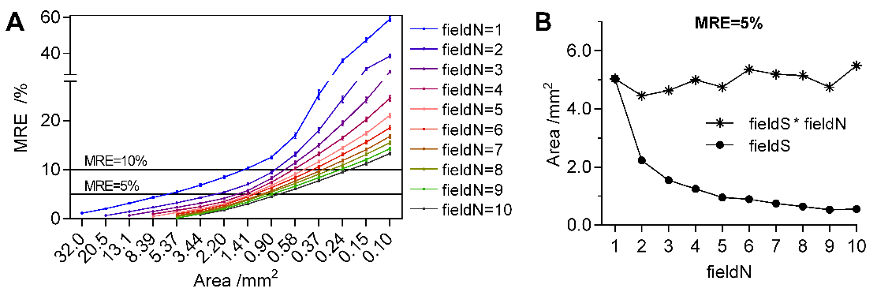
Figure 1. Relative error change with the statistical area
Keywords: Skin, Histology, Image analysis, MinSA algorithm, Hair follicle, Goat

Template 2:
Effect of number and area of view-fields on the measurement accuracy of hair follicle density in goats (Capra hircus)
Jipan Zhang¹, Chengchen Deng^{1,2}, Yongju Zhao^{1*}
¹ College of Animal Science and Technology, Southwest University, Chongqing 400715, China
² College of Veterinary Medicine, Southwest University, Chongqing 400715, China
* Corresponding author: zyongju@163.com
Abstract: Improving the hair follicle density (HFD) has long been a breeding goal, as it can directly affect the fiber yield of fiber-bearing animals, such as cashmere goats, sheep, rabbits and alpacas. Due to sample size and time limitations, the HFD cannot be easily obtained from a large histological area. If the area is too small, the experimental sampling error cannot be ignored. The number of view-fields (fieldN), the area of view-field (fieldS), and the total statistical area (total SA, fieldN×fieldS) needed in the HFD examination have not been determined. Thus, we aimed to develop a strategy to address this unclear topic. A total of 52 goat skin samples were collected, and then performed the paraffin sectioning and hematoxylin-eosin staining. Images of each skin sample were captured, stitched, and clipped. All hair follicles (HFs) were marked manually as color dots, and the background noise was removed. We acquired 52 clean images (50 mm² of stained skin section) and considered 10 types of fieldN, fieldN∈[1,10] and 14 types of fieldS, from 32.0 mm² to 0.10 mm². A Matlab-based algorithm/program, MinSA, was developed to calculate the mean relative error (MRE) under different fieldN and fieldS. In fieldN=1, the field area was 5.04 mm² where MRE reached 5%, indicating that if the field area were less than 5.04 mm² (one field) for the HFD examination, the MRE would be higher than 5%. As the fieldN increased from 2 to 10, the fieldS at 5% MRE gradually reduced, but the total SA increased from 4.45 to 5.49 mm². This result demonstrates that using multiple view-field was not a good choice. In goats, 1-3 fields are recommended, and the total statistical area should be over 5 mm² of stained skin section. Furthermore, this algorithm could apply to other economic fur-fiber animals.
Keywords: Skin, Histology, Image analysis, MinSA algorithm, Hair follicle, Goat

