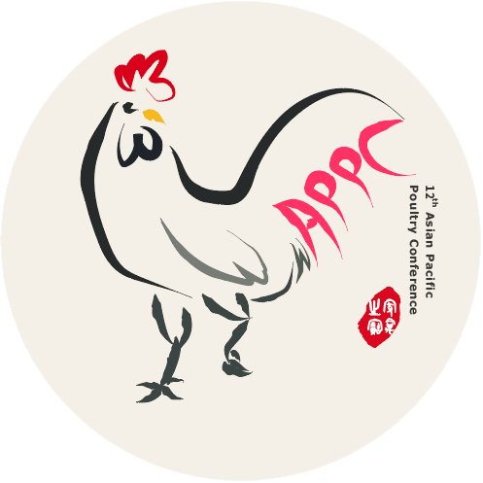
SPONSOR BOOKING FORM
CONTACT DETAILS

Contact Name:
Position:
Name of Company:
Address:
Ofﬁce Tel: Mobile:
Fax: E-mail:

Agreement
• I conﬁrm my support for the APPC 2022
• I conﬁrm that I understand the cancellation charges as detailed in the rules and conditions
• I conﬁrm that I am authorized to sign this document on behalf of the company

SPONSOR INQUIRY*

[ ] Platinum Sponsor
[ ] Gold Sponsor
[ ] Silver Sponsor
[ ] Booth (3x3 sqm)
[ ] Area (6x1 sqm)
RMB 300,000
RMB 150,000
RMB 64,000
RMB 15,000
RMB 9,000

Total area space(s) / booth space(s)

SHOPPING LIST*

[ ] Welcome reception partner
[ ] Lunch Partners/days
[ ] Refreshment Break Partner /times
[ ] Congress bag
[ ] Bottled water Partner
[ ] Notepad & Pen
[ ] Simultaneous interpretation Partner
[ ] Mini Pocket Programme
[ ] Gifts Partner
[ ] Exhibitor Badge
RMB 150,000
RMB 100,000
RMB 50,000
RMB 160,000
RMB 120,000
RMB 120,000
RMB 100,000
RMB 80,000
RMB 50,000
RMB 1,600

*(VAT is not included)

RULES AND CONDITIONS
• The payment should be balanced by May 2022
• The bank fee should not be included in the payment.
• First come first serve basis
• For sponsor, 50% of total payment would be applied for
cancellation before May 2022 and there is no refund after
that period. The cancellation must be written on company
letterhead and submitted to the secretariat office.
• Shopping list is not refundable
Total cost* RMB
Signature:
Date:
Please submit the booking form to
the secretariat ofﬁce at xianghui@boyar.cn

